Median of Two Sorted Arrays

1. There are two sorted arrays A and B of size m and n respectively. Find the median of the two sorted arrays. The overall run time complexity should be O(log (m+n)).

Version 1.0

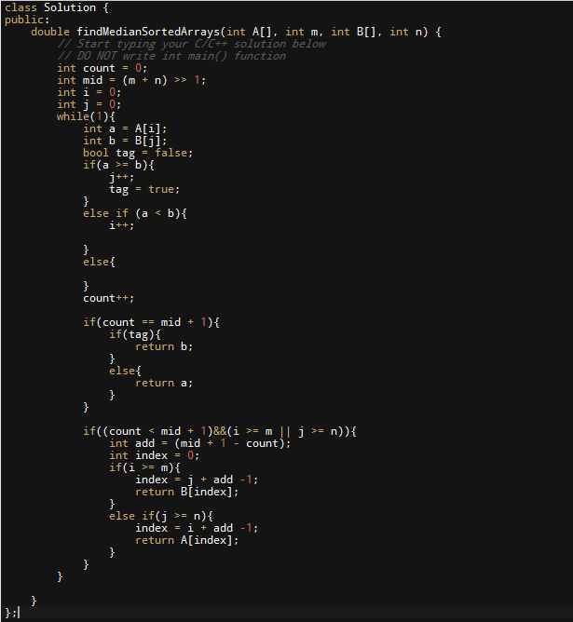

过了600多个case

一共2000多个